PHY101: Introduction to Physics-1
Monsoon, 2020

Tutorial-10

1. Without the wheel, a bicycle frame has a mass of 8.44 kg. Each of the wheels can be roughly modeled as a uniform solid disk with mass of 0.82 kg and a radius of 0.343 m. Find the kinetic energy of the whole bicycle when it is moving forward at 3.35 m/s.

2. At 25 m below the surface of the sea (ρ = 1025 kg/m³), where the temperature is 5°C, a diver exhales an air bubble having a volume of 1 cm³. If the surface temperature of the sea is 20°C, what is the volume of the bubble just before it breaks the surface?

3. We often have the experience of pumping air into bicycle tyre using hand pump. Consider the air inside the pump as a thermodynamic system having volume V at atmospheric pressure and room temperature, 27°C. Assume that the nozzle of the tyre is blocked and you push the pump to a volume 1/4 of V. Calculate the final temperature of air in the pump? (For air , since the nozzle is blocked air will not flow into tyre and it can be treated as an adiabatic compression).

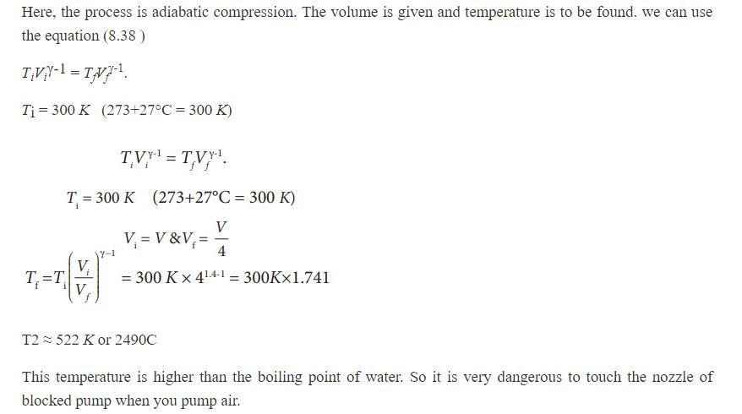

4. Suppose a cylinder of mass M and radius r is rolling down without slipping on an inclined plane making an angle θ with the horizontal plane. Prove that the condition for the cylinder to roll without slipping is given by 1/3 tanθ≤μ_{s}.
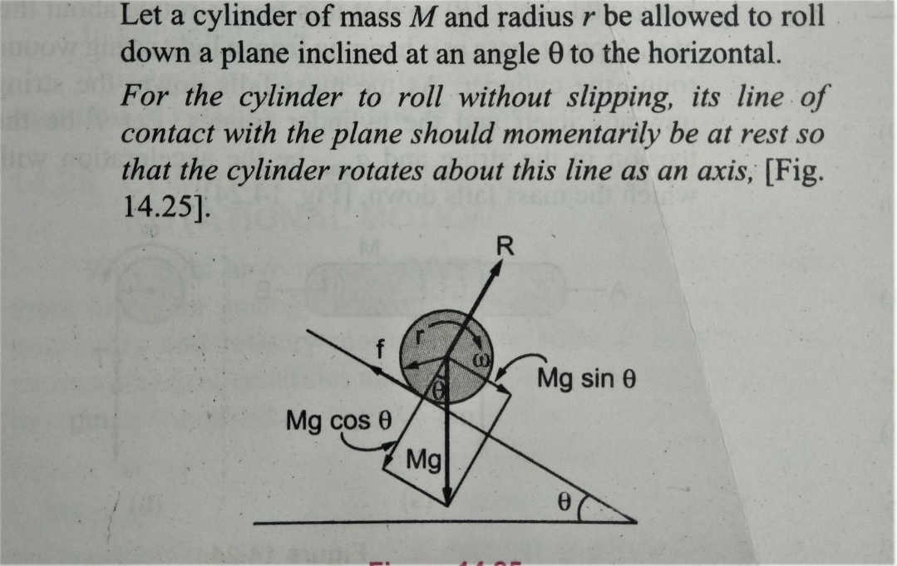

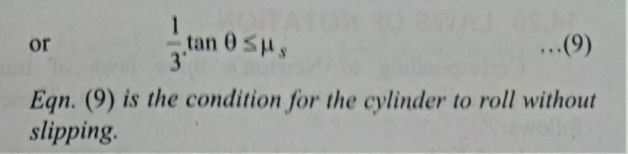
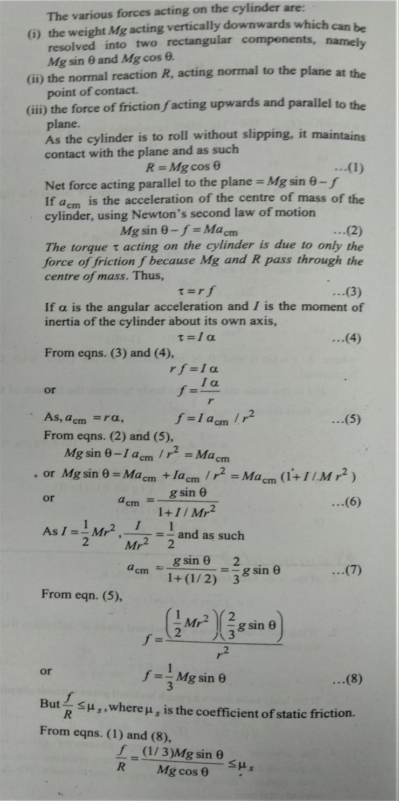
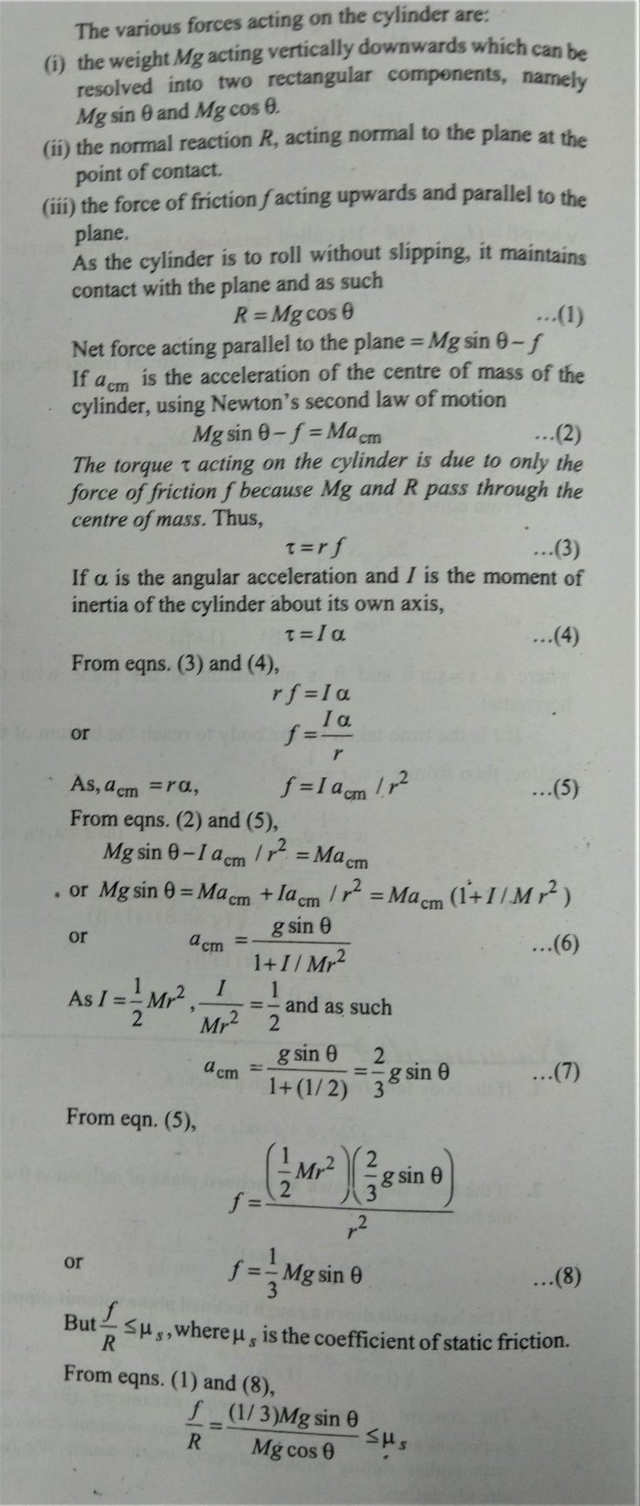

5. The sphere shown in the figure lies on a rough plane when a particle of mass m travelling at a speed v₀ collides and sticks with it. If the line of motion of the particle is at a distance h above the plane, find (a) the linear speed of the combined system just after the collision, (b) the angular speed of the system about the centre of the sphere just after the collision, (c) the value h for which the sphere starts pure rolling on the plane. Assume that the mass M of the sphere is large compared to m so that the centre of mass of the combined system is not appreciably shifted from the centre of mass of the sphere.
